Document Authorization:

 | Name | Date | Signature
Owner | Corin Perrin | 19Jan2022 | See Signature on File
Operation Management | Derek Gauntlett | 19Jan2022 | See Signature on File
Quality Assurance | Emelie Gunter | 19Jan2022 | See Signature on File

Changes from previous version:

Section | Summary of Changes | Change Control Number
ALL | New document initiation for the CMC Analytical Testing Lab in Petaluma, CA. | DCR22040

- PURPOSE
The purpose of this document is to describe the operation and maintenance of the Waters Single Quadrupole SQ Detector (SQD) and SQD2 systems operated by Waters Empower software.
- SCOPE
This SOP describes the operation and maintenance of the Waters SQD and SQD2 MS Systems in conjunction with the Empower Chromatography Data System (CDS) and pertains to all analysis performed within the LCC CMC Analytical Testing Laboratory in Petaluma, CA.
The Waters SQQ and SQD2 are single quadrupole, benchtop mass spectrometric detector that have an embedded PC configuration allows up to 5000 amu/sec scan speeds. With ZSpray technology, these detectors offer sensitive and reliable analyses of samples in complex matrices as well as mobile phases containing non-volatile buffers. The SQD allows a mass range of 2-2048 Da and the SQD2 2-3072 Da (amu). Empower is Waters’ CDS software package for data acquisition, management, processing, and reporting.
The instrument configuration includes parts, model numbers and serial numbers, performance checks, maintenance records, installation OQPV and change control reference are recorded in the relevant instrument binder.
- INTERNAL REFERENCES
Document ID | Title
208849 | Quality Policy
208881 | Validation Policy
208821 | Change Control
208824 | Signatory Authority
208875 | Content, Format, and Use of Logbooks
208903 | Operation and Maintenance of the Waters UPLC System
208943 | Equipment Qualification and Commissioning Procedure
- EXTERNAL REFERENCES
Document ID | Title
ICH Q7 (API) | Good Manufacturing Practice Guidance for Active Pharmaceutical Ingredients
71500126602, Revision E | Waters SQ Detector Operator’s Guide
- RESPONSIBILITIES
Job Function and/or Department | Responsibility
Operational Employees | Employees who prepare, contribute, review or approve SOPs are responsible for adhering to this procedure.  All staff are responsible for ensuring that equipment used in testing activities is qualified and approved for use, as appropriate.
System Owner | As defined in the system logbook. Responsible for organizing calibration and maintenance of the system.  Check and sign-off service reports and calibration certificates
Operational Management | Review of analysis, calibration, and maintenance documentation. Ensure approved third parties or OEM provide instrument calibration and maintenance when required.

- DEFINITION
Term | Definition
AMU | Atomic Mass Unit
APCI | Atmospheric Pressure Chemical Ionization
API Gas | Nitrogen Gas Flow
Da | Dalton
ESI | Electrospray Ionization, may be performed in positive or negative mode
FWHP | Half Width at Maximum
LC | Liquid Chromatography
MS Scan | A detection mode that scans for a range of masses across a designated time frame
MS | Mass Spectrometry
OQPV | Operation Qualification Performance Verification
PSI | Pounds per Square Inch. Unit of measure for pressure.
SIR | Single Ion Reading
SOP | Abbreviation for Standard Operating Procedure provides detailed high-level direction on performing a specific task.
UV | Ultraviolet
- PROCEDURE
  - MS System Setup
    - Open Empower software and log in using Windows login credentials.
    - Select the Run Samples icon, then choose the current month Project folder and Chromatographic System.

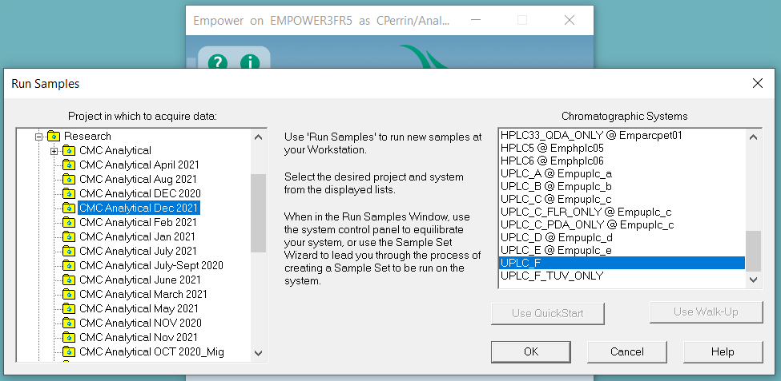

Multiple System options may be available for a particular instrument. Confirm that the system selected includes the configuration for the MS.

    - In the Run Samples window, open the Empower Console by selecting the icon in the Sample Manager tile at the bottom of the window as denoted in red in Figure 2.
    - In the Empower Console, select the MS system component in the left side of the window (ZQ or SQD Detector) then choose Control > Pump from the top toolbar to begin pumping down the MS and evacuating the analyzer. This step can also be performed by opening the MS Tune page (denoted in orange in Figure 2 then selecting Vacuum > Pump from the top toolbar.


Ensure that the rotary pump is ON before attempting to pump down the MS system.
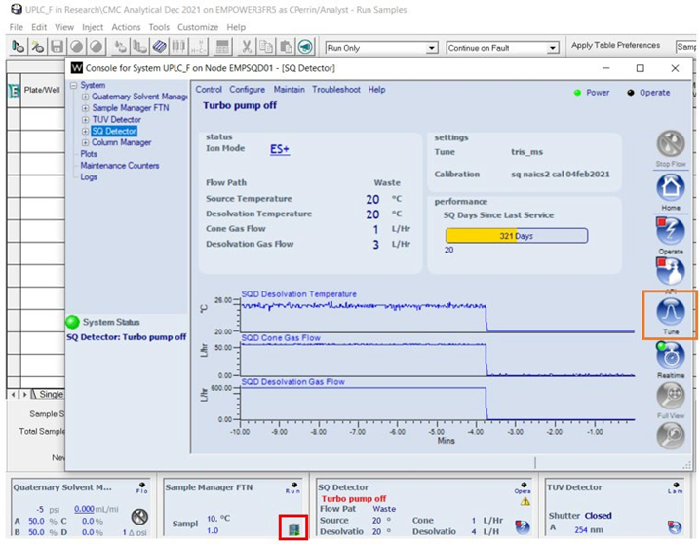
Figure 2 – Opening the Empower Console and MS Tune Pages
    - Monitor the vacuum level in the Tune page by selecting the Diagnostics tap and by clicking the vacuum icon as shown in Figure 3 (red). The instrument’s turbomolecular pump should be within 98% to 100% of turbo speed. This process generally occurs within five minutes; however, overall time to attain turbo speed may be longer with embedded PC initialization.
    - Wait for the instrument to sufficiently evacuate prior to switching the system to Operate from Standby. The MS Tune page will display “Vacuum Ok” along the bottom status bar and the vacuum LED on the instrument’s front panel will indicate adequate vacuum when it stops blinking and remains lit.
    - Nitrogen gas is required for the MS to operate. Check the nitrogen valve behind the instrument and confirm it reads between 90 – 100 psi. Once the pump has reached the specified turbo speed, turn on the API (nitrogen) gas flow by either clicking the API gas icon or by selecting Gas > API Gas from the MS Tune page toolbar (orange in Figure 3).
    - In the MS Tune page, select the Operate button to switch the MS instrument to operational mode. The MS Tune page will display “Ready” at the bottom left corner of the window and the System Status icon in the Empower Console will be illuminated green once the MS is in operational mode.
    - Switch to the ESI+/- tab and update MS detection parameters as required for the samples to be analyzed. Refer to Figure 4 for more details.


Confirm that the Flow State, under the Fluidics tab, is set to LC or else MS data will not be collected.
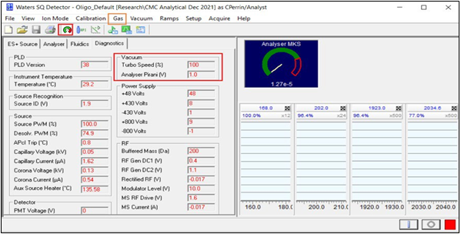
Figure 3 – MS Tune Vacuum and Gas Monitoring
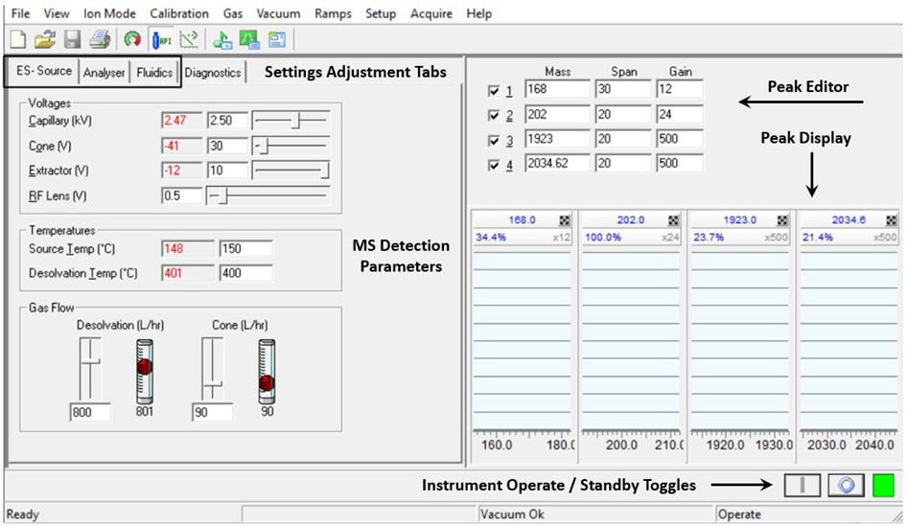
Figure 4 – Setting Tune Parameters for MS Detection
  - MS Calibration System Setup
The Mass Detector acquires data for single ions (SIR) and a range of ions (MS Scan). Follow the subsequent steps for system setup and calibration of the mass scale.
Calibration should always be performed in electrospray mode (ES+ or ES-), even if the intent is to operate in APCI mode (in this case, the ES probe would be removed and replaced with the APCI probe after calibration).
Calibration should be performed monthly or following any scheduled maintenance or repair of the mass spectrometer. Incorrect Mass to Charge ratio readings are another indication the mass scale required calibration.
    - Install the solvent manifold trip tray as shown in Figure 5. The drip tray will collect any solvents or calibration solutions that leak or are spilled from the reservoir bottles.
    - Remove caps of standard size reservoir bottles and screw them onto the instrument. A solution containing sodium cesium iodide is used for MS calibration.
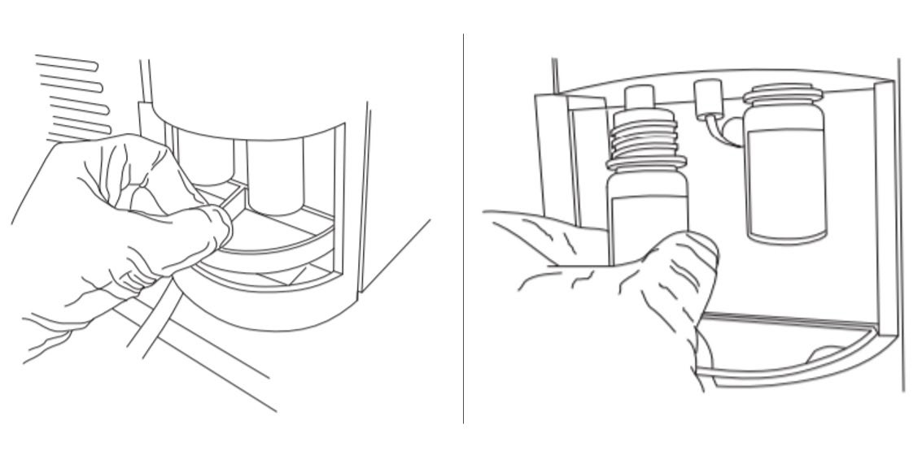
Figure 5 ‒ Installation of the Solvent Manifold Drip Tray (left) and Reservoir Bottles (right) on the Front of the Waters SQ Detector

    - Always purge the instrument lines and the infusion syringe when a new solution is installed. In the Empower Console window, select Control > Purge Fluidics or Control > Refill Syringe under the SQ Detector tab. These tasks can also be performed on the MS Tune page. It may be necessary to purge the system multiple times for certain solutions to minimize carryover.
To clean the system and further reduce carryover between solutions, install a reservoir bottle containing LC/MS grade MeOH or a mixture of 70% MeOH/30% H2O and flush the syringe three times.
    - Confirm that the Fluidics settings are correct prior to starting the calibration run. The Reservoir should be set to either A or B depending on where the calibration solution was installed. The Flow State should be set to Infusion.

Calibrating the Mass Scale
MS calibration should be performed monthly, at a minimum, or as required by a particular method or maintenance procedure.
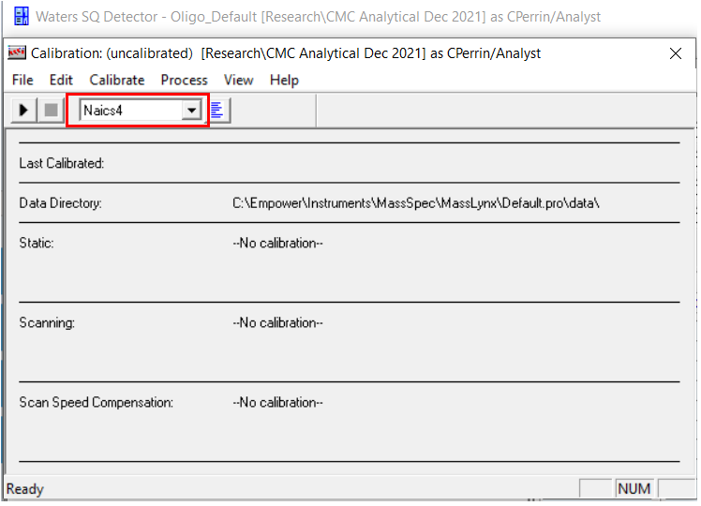
    - Before calibrating, remove the current calibration file and select a reference file. In the MS Tune page, select Calibration > Calibrate Instrument from the top toolbar. The calibration window will pop up, as shown in Figure 6.
Figure 6 ‒ MS Tune Page Calibration Window

    - Select Naics4 from the Reference File drop-down list. Ensure that “No calibration” is displayed next to the sections for Static, Scanning, and Scan Speed Compensation.
    - Confirm that the data directory listed is correct. This is where the calibration result file will be stored.
    - Select File > Save As to name the new calibration file. At minimum, the file name should include the date calibrated.
    - Click the black arrow (play) icon as shown in Figure 7. The Automatic Calibration window will pop up.
    - Confirm that the appropriate calibration types and process steps are selected. Click the Acquisition Parameters button to set additional calibration parameters specific to the MS acquisition.
    - Confirm that the Scan To mass range extends to the limit of the MS instrument being calibrated (e.g., 2048 Da for SQD or 3072 Da for SQD2).
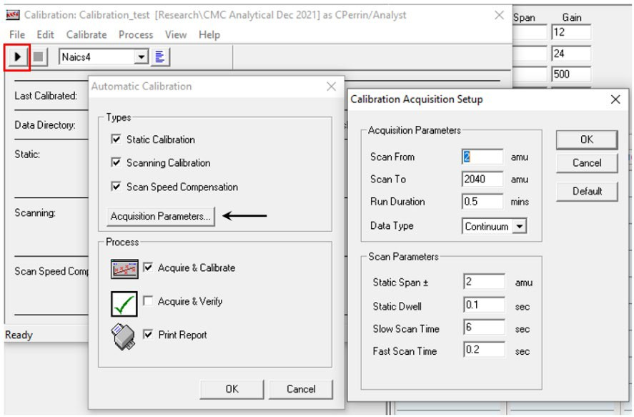
    - Click Ok on all windows once parameters are confirmed to start the instrument calibration.
Figure 7 ‒ SQ Detector Automatic Calibration Parameter Selection

    - The instrument will begin scanning based on the information entered in the reference file.
    - Once complete, a window will pop up indicating if the calibration passed or failed.
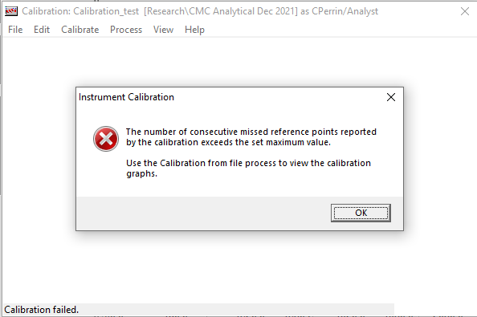

Figure 8 ‒ Failed MS Calibration Window

    - Review graphs generated during the calibration by selecting Calibrate > From File in the main calibration window.
    - Select the Calibration Type (Static, Scanning, and Scan Speed Compensation) and Calibration File (this automatically updated when the calibration type is changed).
    - When the calibration graph window appears, confirm the number of matches indicated near the top right side of the window.
    - Manually review the data points evaluated in order to identify any mismatches.
    - Print the calibration graphs, as required, by selecting File > Print from the top toolbar.
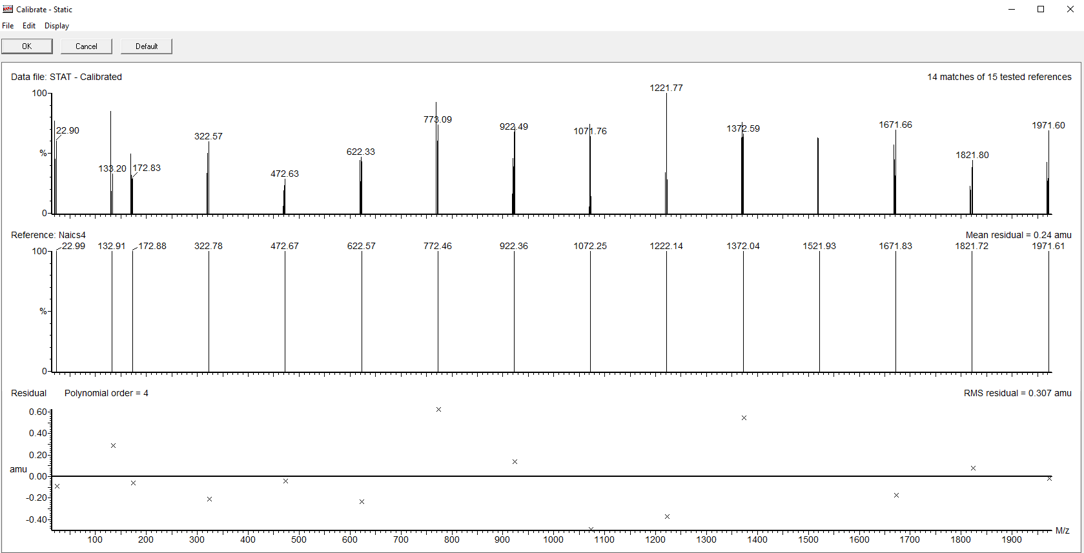
Figure 9 ‒ MS Calibration Graph

    - Close the window by clicking Ok. If the calibration passes, select Accept Calibration if prompted to do so.
    - If the calibration fails, confirm which calibration type, or types, needs to be rerun. Check the system setup and attempt the calibration again. Change the calibration solution if it is not freshly prepared.

